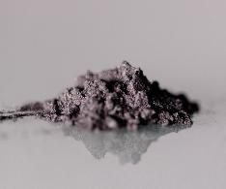
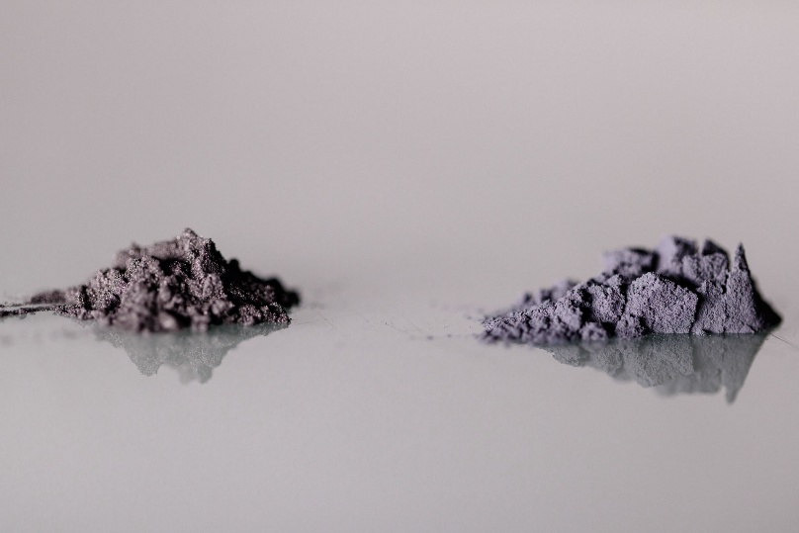
Home

ENWIRES

Who Are We?
Example content (1 to 2 paragraphs)
Enwires is currently composed of a team of around ten employees and is supported by several experts from the industrial sector. The company aims to contribute to innovation in the field of lithium-ion batteries.
Aware of the challenges and limitations associated with this technology, we strive to support its development by creating solutions that enhance energy density and overall performance in one of the most widely used technologies of modern society.

What Do We Offer?
Example content (2 to 3 paragraphs)
Enwires develops solutions designed to improve both the energy density and the lifespan of lithium-ion batteries.
Our technology enhances the performance of materials used in today's batteries and significantly increases their energy capabilities. Thanks to these improvements, future batteries will be able to deliver higher performance at the same volume, or maintain current performance levels while reducing their size and weight.



Product

SiBoost
What is SiBoost?
Example content (1 to 2 paragraphs)
SiBoost is the name of our product: a silicon-doped graphite designed to enhance the performance of lithium-ion batteries.
Thanks to our technology, we are able to produce a graphite-silicon composite (Gr-Si) that combines the electronic conductivity of graphite with silicon's ability to interact with and store lithium ions. This composite offers increased energy density, reaching between 1.1 and 4 times the performance of the graphite currently used in lithium-ion batteries.
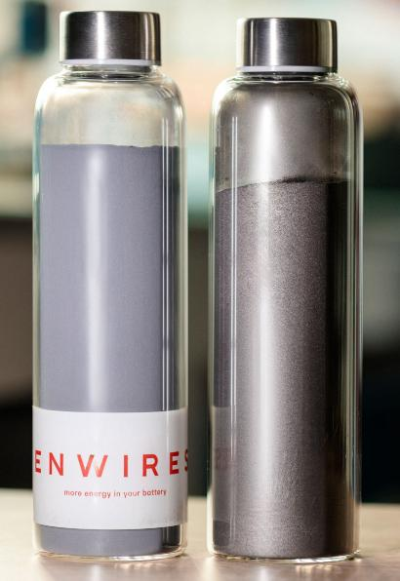
Thanks to our production line, we can adapt our process to most graphite materials used within the industry. This flexibility also creates opportunities to make use of materials that are currently underutilized because of their specific characteristics.



